DepHNN: A Hybrid CNN–LSTM Approach for EEG-Based Depression Detection

Badrinath K
Assistant Professor
Department of Artificial Intelligence and Data Science
SJC Institute of Technology
Chikkabalapura, Karnataka, India
badrik86@gmail.com

Sandhya R
Assistant Professor
Department of Artificial Intelligence and Data Science
SJC Institute of Technology
Chikkabalapura, Karnataka, India
sandhyachandran.ds@sjcit.a.in

Mareddy Charan
Department of Artificial Intelligence and Data Science
SJC Institute of Technology
Chikkabalapura, Karnataka, India
charanmareddy26@gmail.com

Balappagari Latha Sree
Department of Artificial Intelligence and Data Science
SJC Institute of Technology
Chikkabalapura, Karnataka, India
lathasree.balappagari@gmail.com

Chagaleru Sathyanarayanagari Mounika
Department of Artificial Intelligence and Data Science
SJC Institute of Technology
Chikkabalapura, Karnataka, India
mounimounika2897@gmail.com

Abstract- Major depressive disorder (MDD) is a common mental health disorder affecting mood regulation, cognition, and physical condition. Its clinical diagnosis is often imprecise because of symptom overlap with other psychiatric disorders. EEG represents a widely available, noninvasive, and objective method for the investigation of brain activity related to the depressive state with high temporal resolution. This work proposes DepHNN, a hybrid deep learning architecture that combines Convolutional Neural Networks (CNN) with Long Short-Term Memory (LSTM) units for automatic depression detection from raw EEG recordings. The CNN layers in this architecture learn the representation of both spatial and spectral information of multi-channel signals, while LSTM layers model the temporal variations that are typical of neural patterns related to MDD. The dataset consists of EEG signals from 34 subjects with diagnosed depression and 30 healthy subjects, recorded under eyes-open, eyes-closed, and P300 task conditions using a 19-channel 10–20 electrode system at 256 Hz. At the preprocessing step, filtering, normalization, and windowed segmentation were applied to make the signal more consistent. The proposed model reached an accuracy of 98.27%, with a mean absolute error of 0.0237, outperforming other conventional machine learning and single-network approaches. From these results, it is evident that the hybrid framework has successfully learned the spatial and temporal biomarkers of EEG signals related to depressive disorders. In future studies, attention is given to work on the multimodal inputs and real-world deployment of the proposed architecture for clinical screening.
Keywords - Depression detection, Electroencephalography (EEG), Convolutional Neural Network (CNN), Long Short-Term Memory (LSTM), Hybrid deep learning, Major Depressive Disorder (MDD), Automated diagnosis.

- INTRODUCTION

Depression is among the most prevalent neuropsychiatric disorders worldwide and has been rated by the World Health Organization as a leading cause of disability among populations of virtually all ages worldwide [1]. Over the last ten years, prevalence rates have demonstrated an approximately 18% increase, with significantly high rates among females as compared to males [2]. Clinical manifestation significantly varies between and within individuals in terms of severity: there is persistent sadness, loss of motivation, impairment of cognitive function, loss of interest in activities, feelings of worthlessness, and recurrent thoughts of self-harm or suicide in severe forms of the disorder [3]–[5].

A majority of 50% are not diagnosed or treated due to several reasons, such as lack of awareness, non-trained medical staff, use of minimal resources, and incorrect diagnosis [5]. Diagnosis at an early stage is imperative, and computer-aided solutions based on hybrid deep learning frameworks, such as CNN combined with LSTM, are considered promising approaches for high-accuracy, low-complexity depression detection.

Due to its non-invasive, cost-effective, and real-time signal acquisition properties, EEG has become a promising biomarker for diagnosing neurological and psychiatric disorders [6]–[8]. EEG monitors the electrical activity of the brain as a function of time (Fig. 1); however, the recorded signals are inherently complex and noisy, which makes their manual analysis cumbersome [9].

Various machine learning methods [6]–[14] and several deep learning approaches [15]–[30] have been proposed during the last years for the analysis of EEG data to identify neurological and psychiatric disorders such as Alzheimer’s disease [31], epilepsy [32], Parkinson’s disease [34], seizures [36], schizophrenia [38], and emotion recognition. Furthering those works, this paper uses EEG signals as a biomarker for developing a computer-aided depression detection system through a hybrid architecture combining CNN with LSTM. The rationale behind this approach lies in the fact that both spatial and temporal patterns are captured in EEG signals to provide a powerful automated diagnostic tool for depressive disorders.

- RELATED WORK
In the last few years, EEG signals have been gaining more attention in the automatic diagnosis and detection of MDD conditions. Previous related work relied heavily on manually designed features from EEG signals, followed by the classification tasks using traditional machine learning models. However, deep learning enables researchers to explore data-driven methods that could determine discriminative features directly from raw EEG inputs. Subsequently, architectures such as CNNs and RNNs prove to bring obvious improvements for classification performance because they could automatically learn spatial or temporal representations. Works reviewing literature therefore reflect the tendency of transitioning from the traditional model dependent on features to more sophisticated hybrid frameworks. Particularly in this trend, the CNN–LSTM paradigm proves effective in seamlessly integrating spatial feature extraction and sequential pattern learning.
- Early Approaches Reliant on Handcrafted EEG Features

Features extracted in initial research included statistical, spectral, and nonlinear features from the preprocessed recordings. Spectral power analysis and frontal alpha asymmetry have been reported in many studies as reliable biomarkers of depression [1], [2]. Common feature descriptors include Power Spectral Density (PSD), differential entropy, and complexity measures such as Sample Entropy. Classifiers such as Support Vector Machines (SVM), K-Nearest Neighbors (k-NN), and Artificial Neural Networks (ANNs) have often been used in such studies [1], [2].

For example, various studies reported accuracies within the 80–90% range, having strong reliance on handcrafted features and domain expertise [1]. However, these traditional methods are not capable of capturing the non-linear, high-dimensional, and temporally dependent structure of EEG signals, thus limiting scalability and robustness.

B. Deep Feature Learning Approaches for EEG Analysis

1) Convolutional Neural Networks (CNNs)

As a result, CNNs have become popular for EEG-based analysis due to their superior capability of extracting meaningful spatial and spectral patterns from multichannel recordings without using handcrafted features. Instead of designing feature sets manually, the EEG data can be transformed into a one-dimensional or two-dimensional time–frequency format and presented directly to the deep neural network for the convolutional layers to learn the activity patterns of interest. Previous studies, such as that of Li et al. [3], focused on deep CNN architectures that are much more capable of identifying small-scale, localized neural signatures implicated in depressive conditions. Furthermore, surveys of studies such as that presented in [4] highlight how CNN-based approaches have increasingly been adopted instead of traditional machinelearning pipelines in EEG classification tasks, as they offer strong generalization ability with a built-in feature extraction process.

2) Long Short-Term Memory(LSTM)

Given the sequential nature of EEG signals, LSTMs have been widely utilized to model long-term temporal dependencies related to depressive brain dynamics. Experimental validation in [5] and [6] demonstrated the ability of LSTM models to outperform conventional machine learning algorithms by capturing temporal changes in EEG sequences. While LSTMs excel in modeling time-dependent features, they often fail to perceive spatial-spectral structures that CNNs are better suited to extract.

C. Hybrid CNN–LSTM Architectures
The hybrid deep-learning pipelines that combine convolutional and recurrent structures have gained strong traction in EEG classification research, especially for depression analysis. In these systems, CNN layers first extract spatial and spectral cues from the signal, while the subsequent LSTM units interpret the evolving temporal behavior within the sequence. Various recent studies report that the combined models systematically outperform architectures based only on CNNs or only on LSTMs. Improvements are not only in terms of accuracy but also robustness to noise and strength of generalization. For instance, several studies using 1-D CNN combined with LSTM on preprocessed EEG windows have reported recognition rates of more than 98%, underlining the advantage of modeling both localized neural signatures and their time-dependent evolution. General literature reviews also point out that hybrid approaches now represent one of the most effective design choices for EEG-based depression detection, since they fully exploit both dimensions of the signal: spatial structure and temporal progression.
Our proposed CNN–LSTM model follows this highly successful paradigm: first extracting the spatial–spectral representation using CNN, followed by LSTM-based temporal modeling. This dual-stage architecture allows for efficient representation learning and follows trends reported by state-of-the-art research.

RATIONALE BEHIND THE PROPOSED HYBRID CNN–LSTM MODEL

A. Motivation for Hybrid CNN–LSTM Architecture

The CNNs indeed demonstrated very strong capabilities in the extraction of spatial and spectral features from multi-channel EEG data. But it has some limitation in order to model temporal dependencies, which are present in any time-series signal, such as EEG. In contrast, LSTM networks are designed to model sequential data using learned long-range temporal dependencies based on a memory composed of gated units, hence effectively avoiding the vanishing gradient problem encountered in traditional RNNs [17].

The idea of using a hybrid structure for depression detection is motivated by the complementary strengths of the CNN and LSTM. In this setup, the CNN component extracts salient spatial and frequency-domain features in the preprocessed segments of EEG, while the LSTM component models the temporal evolution of these features. This approach allows for end-to-end learning from raw EEG signals, eliminates the need for manual feature engineering, and improves classification performance in the detection of depressive disorders.

B. Dataset and Pre-processing
The current study uses a freely available EEG database that includes recordings from patients suffering with MDD, as well as neurologically healthy controls. The dataset consists of 34 MDD subjects (17 males and 17 females; mean age ≈ 40.3 ± 12.9 years) and 30 unaffected controls (21 males and 9 females; mean age ≈ 38.3 ± 15.6 years). EEG signals were recorded in three experimental conditions: eyes-open, eyes-closed, and during a P300 cognitive task. All the signals were recorded using a 19-channel electrode layout according to the international 10-20 positioning standard, and the recordings were sampled at 256 Hz, resulting in multichannel time-series data adequate for analysis of neural patterns and deep learning-based classification.
These signals were processed in a structured preprocessing pipeline before being fed into the model to reduce noise and ensure signal consistency. Major steps included:
1. Band-pass filtering to retain the relevant neural frequencies and reject low and high-frequency noise.
2. Artifact removal to eliminate contamination from eye blinks, muscle movements, and environmental noise.
3. Segmentation using a windowing approach: This is used to transform continuous EEG recordings into fixed-length time windows suitable for CNN input.
4. Normalization: to scale the signal amplitudes consistently across channels and subjects, enabling stable model convergence.
This preprocessing pipeline ensures that both spatial and temporal patterns inherent in the EEG signals are preserved while reducing the noise and variability, and provides an optimal input for the subsequent hybrid CNN-LSTM model.
- DEPHNN: PROPOSED SPATIO-TEMPORAL EEG CLASSIFICATION FRAMEWORK

The depression classification system developed in this research, termed DepHNN, is a hybrid deep-learning model designed to learn both the spatial and temporal dynamics exhibited in multi-channel EEG recordings. This architecture employs a convolutional module to learn the spatial and frequency-based patterns from the raw signal, followed by stacked LSTM layers that capture sequential dependencies across time. The learned features are then fed into dense layers responsible for the decision-making task of final classification after feature learning. To make the network more reliable and reduce the risk of overfitting during network training, Dropout regularization is embedded within the network. The combination of this structure allows the model to ensure high generalization performance when assessing previously unseen EEG data.

- Spatial Feature Learning with Convolutional Layers
The CNN block in the proposed DepHNN architecture works to ensure that significant local features are extracted from the raw multichannel EEG signals. EEG signals are very noisy, nonstationary time-series data; therefore, an effective feature extraction mechanism is essential prior to sequence learning. This is what CNNs do well: by applying learnable kernels across the input, one allows automatic learning of frequency- and time-localized patterns.
In this architecture, EEG windows size 19 × 256 (channels × time samples) will be fed at the input of a 1D convolutional layer which has 64 filters each with kernel size 5 and stride 1. This kernel size will enable it to capture short-term temporal dependencies and frequency-specific information that may correspond to neural activity patterns related to depression. Mathematically, the convolution operation can be defined as:
$$y(t) = (x * w)(t) = Σ x(t - k) · w(k)$$
Where,
x (t) denotes the input EEG signal,
w(k) represents the convolutional kernel, and
y(t) is the resulting feature map.
In this architecture, one 1D convolutional layer is utilized with 64 filters and a kernel size of 5. This kernel size was chosen empirically because it effectively captures temporal characteristics above 4 Hz, which are known to carry neurological significance in EEG-based depression detection. The output of the convolutional layer provides a changed representation in shape (64,T′), where T′ is the reduced temporal dimension after convolution.
The Rectified Linear Unit (ReLU) activation is applied to introduce non-linearity and improve gradient propagation. ReLU is defined as:
$$f(x) = max(0, x)$$

This activation suppresses negative activations while allowing positive values to propagate; this makes the model more robust and computationally efficient. Further, the extracted CNN features are forwarded to the LSTM block to learn sequentially.

B. Learning Model with LSTM
Long Short-Term Memory, introduced by Hochreiter and Schmidhuber [60], was developed to model such sequential learning tasks present in time-dependent data. Since EEG signals denote the neural activity on a continuum, they will, by nature, exhibit temporal variations over brief and extended periods; thus, LSTM-based architectures are highly suitable for distinguishing depressive patterns.
Unlike standard RNNs, which often suffer from the problem of vanishing gradients when dealing with long sequences, LSTMs tackle this limitation by utilizing a gated memory mechanism. Such an architecture allows the model to capture and update crucial temporal information over longer periods than would have been possible; thus, enhanced feature learning and improved discrimination between healthy and depressive EEG recordings are achieved.
As shown in Fig. 1, the LSTM cell consists of four key components:
(1) Forget gate,
(2) Input gate,
(3) Candidate memory update
(4) Output gate

The LSTM block in the proposed DepHNN model uses the sequence of feature vectors extracted from the CNN layer. Let the output of CNN be represented as Xt, where t denotes the time step. The LSTM consists of two types of memory: the long-term cell state Ct-1 and the short-term hidden state ht-1. The LSTM gates function in the following ways:

The forget gate decides which part of the previous memory should be retained.

The input gate selects new information to update the memory.

The candidate memory supplies new material depending on the given input.

The output gate generates the updated hidden state, which is passed to the next time step.

The LSTM block will learn meaningful temporal dependencies in the EEG signals through this gated mechanism, thereby providing this network with the capability of distinguishing stable temporal patterns associated with depressive and non-depressive brain activity.

C. Overall Architecture of the DepHNN Framework
The complete design of the proposed hybrid deep learning system, called DepHNN, is shown in Fig. 2. Designed to capture both spatial patterns and the temporal sequence within EEG data, it aims to classify individuals reliably as either depressed or healthy. The architecture consists of six stages that are connected sequentially, with each block transforming the input and passing on the learned representations. The architecture takes in EEG data in the form of sequences from 19 channels, each with 256 time points, making sure that during training both local neural patterns and long-range temporal relationships can be captured.
First, we apply a 1-D Convolutional Layer to the multichannel EEG input to extract low-level spatial patterns. The kernel size of 5 along with 64 filters has been shown to effectively capture local temporal dynamics in EEG signals. We then use the ReLU activation function to introduce nonlinearities and enhance the discriminability of the features. The convolutional output is rearranged by a Permute layer to prepare the features for later temporal sequence modeling.
Layers 2 and 3 include a pair of sequential LSTM modules that are configured, respectively, with 64 and 32 neurons. Their aim is to capture both the short-range fluctuations and the extended temporal trends within the EEG windows. In such a configuration, the first LSTM layer outputs the entire sequence rather than a single summary value, ensuring that temporal continuity is preserved for further processing. Finally, the second LSTM layer collapses such a sequence into a final temporal representation that feeds the later classification layers. Right after the LSTM stack, in order to prevent model overfitting and enhance its ability to generalize to unseen data, there is a Dropout mechanism with probability 0.5.
Layers 4 and 5 introduce two successive fully connected units, each comprising 16 neurons with ReLU activation. These layers refine and compress the feature representation generated by earlier stages into a more discriminative form suitable for classification. To prevent overfitting during training, a dropout mechanism with a probability of 0.5 is applied straight after the first dense layer, promoting robustness and generalization.
The softmax output layer in Layer 6 contains the final 2 neurons, corresponding to the two diagnostic classes: Depressed and Healthy. The model is trained by minimizing the Huber Loss because it has robustness to outliers, which are commonly present in physiological data.
A detailed description of each layer and associated parameters of the proposed DepHNN architecture is provided in Table 1

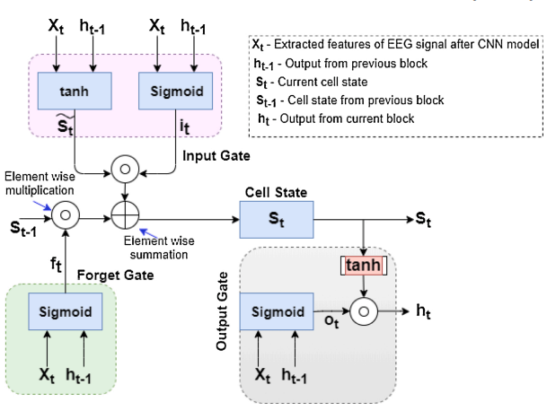
Fig. 1 LSTM Architecture

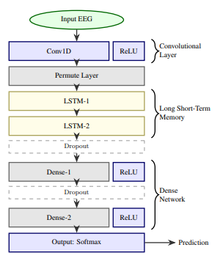
Fig. 2 Proposed Architecture
Table 1
Structural Breakdown of the Proposed Hybrid Neural Architecture
S. No. | Name of Layers | Kernel | Parameters of Layers | Parameters (Count)
1 | Convolution (1D) | 64 × 5 | Filters=64, Stride=1, ReLU Activation, Input Channels=19 | 6,144
2 | LSTM | None | Unit size = 64, Return Sequence = True | 33,024
3 | LSTM | None | Unit size = 32, Return Sequence = False | 12,416
4 | Dense | None | Unit size = 16, ReLU Activation, Dropout=0.5 | 528
5 | Dense | None | Unit size = 16, ReLU Activation, Dropout=0.5 | 272
6 | Dense (Output) | None | Unit size = 2, Softmax Activation | 34
Table 2
Comparative Evaluation of the Proposed DepHNN Model Against Alternative Deep Learning Architectures
Model | Layer | Type | Total Parameters | Time per Epoch (s) | Loss
Model_1 | 1  2  3  4 | Conv  LSTM  Dense  Output | 32,518 | 108 | 0.31
Model_2 | 1  2  3  4  5 | Conv  LSTM  LSTM  Dense  Output | 51,240 | 152 | 0.24
Model_3 | 1  2  3  4 | LSTM  LSTM  Dense  Output | 43,112 | 120 | 0.29
Model_4 (no CNN) | 1  2  3  4 | LSTM  LSTM  Dense  Output | 72,890 | 205 | 0.22
DepHNN (Proposed) | 1  2  3  4  5  6 | Conv  LSTM  LSTM  Dense  Dense  Output | 46,658 | 112 | 0.20

RESULTS AND DISCUSSION
The proposed CNN–LSTM system was trained and evaluated on a workstation running an Intel Core i7 processor operating at 2.30 GHz and supported by 12 GB DDR4 memory. Model development and experimentation have been implemented in Python with the Keras deep-learning library. The network was optimized using the Adam optimizer, and a batch size of 64 was considered during training. The EEG dataset was randomly partitioned into three subsets based on the benchmark ratio: 70% for model learning, 20% for validation, and 10% for final testing. Based on this partitioning, the training phase leveraged 9,248 EEG segments, while 2,563 samples were assigned for validation, and 1,000 segments were retained for the test set.
Table 2 provides the performance comparison between the six-layer CNN-LSTM model and several alternative architectures, which were made up of different combinations of convolutional, LSTM, and dense layers. The hybrid model performed better in terms of loss reduction and efficiency during training. Models with multiple LSTM layers, such as Model_1 and Model_2, took longer computation time per epoch (103 s and 152 s, respectively) with higher losses. Model_3 utilized an increased number of dense layers rather than stacking additional LSTM layers to reduce training time while improving stability. Fully LSTM layer models, similar to Model_4, illustrated reduced loss but resulted in much higher computation times, coming to 205 s per epoch.
The final architecture strikes an effective balance between computational efficiency and the learning capability involving temporal-spatial feature extraction and sequence modeling. Running at roughly 112 s per epoch with a loss of 0.20, it compares quite favorably to the other architectures under evaluation here using identical conditions.
Evaluation on the unseen test set of 10% of total data yielded an accuracy of 98.27%, with MAE equal to 0.0237. It is noted that out of the 1000 EEG test samples, only a small number of signals were misclassified, indicating a reliable discriminative ability. These findings are consistent with both the confusion matrix and accuracy-loss plots, which demonstrate consistent convergence and low generalization error.
A number of existing studies have explored EEG-based diagnosis of neurological and mental health conditions using traditional machine learning and modern deep learning approaches. Methods relying on handcrafted signal descriptors—such as entropy measures, wavelet coefficients, and nonlinear complexity features—often result in reasonable but limited accuracy because their performance is always dependent on manual feature engineering and domain expertise. With the increasing availability of neural network-based frameworks, models that learn representative features automatically from the EEG recordings have shown improved diagnostic capability. Hybrid deep learning architectures, especially those combining convolutional layers with recurrent networks, demonstrated promising performance for the detection of depression. To mention a few, CNN–LSTM-based models, as reported in earlier literature, such as the work by Ay et al. [37], reached an accuracy of almost 97.66%. Compared to that, the proposed hybrid DepHNN framework, when applied to the same EEG dataset, achieved an accuracy of 98.27% without the need for manually designed features.
This integrated CNN-LSTM structure allows the model to learn from both short-term fluctuations and long-range patterns of EEG recordings for the effective analysis of both localized signal characteristics and temporal progressions. In fact, this combination has presented salient performance advantages over many prior machine learning and deep learning frameworks developed for EEG-based neurological evaluation, thus presenting this model as suitable for reliable depression classification.
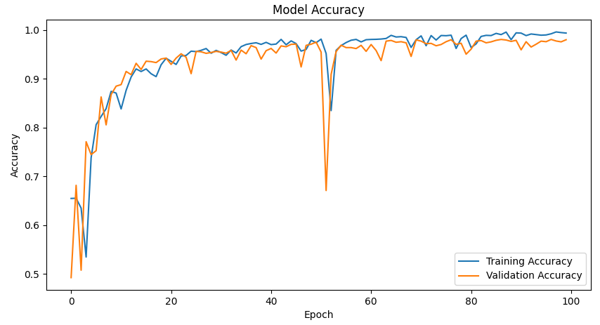
Fig. 3 Accuracy values for the proposed model.
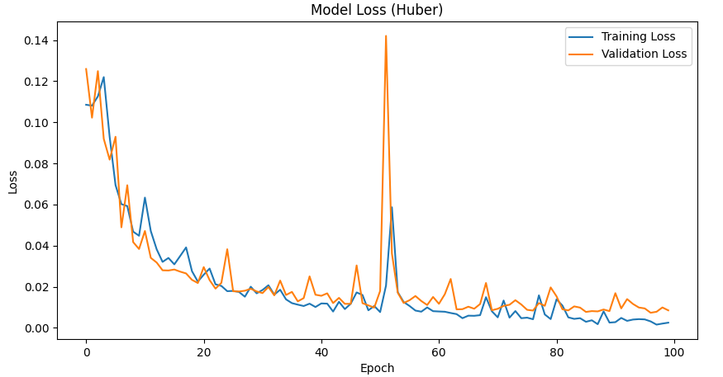
Fig. 4 Loss values for the proposed model.
- CONCLUSION AND FUTURE RESEARCH
The hybrid architecture of CNN-LSTM developed in this work shows an excellent capability to identify depressive patterns from EEG signals. The convolutional layers capture the local temporal-spatial structures, and LSTM layers model the long-range temporal dependencies representative of neurological activity. The proposed model yields an accuracy of 98.27% with a mean absolute error of 0.0237, showing reliable performance in classifying depressed subjects from healthy controls. Stable learning and consistent classification outcomes are achieved by the feature extraction process and network design and training strategy. Results indicate that convolution-based representation learning in combination with recurrent temporal modeling is quite effective for EEG analysis pertaining to mental health.

The system can be scaled up by integrating large and varied EEG data to enhance generalization across age groups, clinical conditions, and recording environments. Attention mechanisms could be incorporated to help the network identify the most informative EEG segments, enhancing interpretability. Real-time deployment using optimized lightweight versions of the model can be extended for both clinical and home-based monitoring systems. Multimodal fusion with behavioral, speech, or physiological data may strengthen prediction reliability in complex diagnostic settings. Expansion into a continuous-monitoring framework using explainable AI modules will help support clinicians with more transparent and actionable insights.

REFERENCES
[1] World Health Organization, Depression and Other Common Mental Disorders: Global Health Estimates, Technical Report, WHO Press, 2017.
[2] Efficient Anomaly Identification and Segmentation Using Optimization Based Fuzzy Clustering Approach, R. P., A. Tilagul, Badrinath K, K. Ramaraj, T. M., and P. A. S. Surendhar, 2024
[3] World Health Organization, “Depression Fact Sheet,” 2021.
[4] American Psychiatric Association, Diagnostic and Statistical Manual of Mental Disorders (DSM-5), 5th ed., Washington, DC, USA, 2013.
[5] M. Marcus, et al., “Depression: A Global Public Health Concern,” World Health Organisation Report, 2012.
[6] U. R. Acharya, et al., “Automated Diagnosis of Depression Using EEG Signals,” Computer Methods and Programs in Biomedicine, 2018.
[7] B. Hosseinifard, M. Moradi, and H. Rostami, “Classifying Depressed and Normal Subjects Using Nonlinear EEG Features,” Clinical Neurophysiology, 2013.
[8] M. Mohammadi, et al., “EEG Biomarkers in Psychiatric Disorders: A Review,” Neuroscience Letters, 2020.
[9] U. R. Acharya, V. K. Sudarshan, et al., “A Depression Diagnosis Index Using EEG Signals,” European Neurology, 2015.
[10] M. Ahmadlou, H. Adeli, and A. Adeli, “Fractal Analysis for Major Depressive Disorder,” International Journal of Psychophysiology, 2012.
[11] M. Bachmann, et al., “Classification of Depression Using Single-Channel EEG,” Computer Methods and Programs in Biomedicine, 2018.
[12] M. Kaya and M. Uyar, “Support Vector Machine-Based Depression Detection Using EEG Signals,” Expert Systems With Applications, 2014.
[13] S. D. Puthankattil and P. K. Joseph, “Classification of EEG Signals in Normal and Depression Conditions Using ANN,” Journal of Mechanics in Medicine and Biology, 2012.
[14] Y. Ding, X. Chen, Q. Fu, and S. Zhong, “Depression Recognition Using Deep Integrated Support Vector Algorithm,” IEEE Access, 2020.
[15] R. G. Andrzejak, et al., “Nonlinear Deterministic Structures in EEG,” Physical Review E, 2001.
[16] U. R. Acharya, S. L. Oh, Y. Hagiwara, J. Tan, and H. Adeli, “Deep Convolutional Neural Network for Automated Seizure Detection,” Computer Methods and Programs in Biomedicine, 2018.
[17] A. Craik, Y. He, and J. L. Contreras-Vidal, “Deep Learning for EEG Classification: A Review,” Journal of Neural Engineering, 2019.
[18] X. Li, et al., “Recognition of Mild Depression Using CNN Models,” IEEE Access, 2020.
[19] Y. Yang, et al., “Emotion Recognition Using Convolutional Neural Networks,” Information Sciences, 2018.
[20] M. Murugappan, et al., “Deep Learning Models for EEG-Based Emotion Analysis,” Sensors, 2020.
[21] R. Duan, et al., “Emotion Recognition Using Hybrid CNN-LSTM Architecture,” IEEE Transactions on Cognitive and Developmental Systems, 2021.
[22] Y. Luo, et al., “EEG Classification Using CNN-RNN Hybrid Architectures,” Pattern Recognition, 2020.
[23] H. Amin, et al., “Long Short-Term Memory Networks for EEG Classification,” Neural Computing and Applications, 2020.
[24] B. Zhou, et al., “End-to-End Deep Learning Framework for EEG Signal Analysis,” Frontiers in Neuroscience, 2019.
[25] X. Zhu, et al., “Hybrid CNN-LSTM Model for Emotion Recognition Using EEG Signals,” IEEE Access, 2019.
[26] T. Tuncer, et al., “Hybrid CNN-LSTM Framework for EEG-Based Depression Detection,” Expert Systems With Applications, 2022.
[27] Z. Yin, et al., “Deep Learning Framework for Emotion EEG Classification,” IEEE Transactions on Affective Computing, 2022.
[28] S. Chen, Y. Yu, and J. Pan, “MADNet: Multi-Dimensional Attention CNN for EEG-Based Mental State Prediction,” Proceedings of ICANN, 2023.
[29] W. Zhao, et al., “Hybrid CNN-RNN for Major Depressive Disorder Recognition Using EEG,” IEEE Access, 2020.
[30] A. Hosseini, et al., “Deep Learning Approaches for EEG-Based Major Depressive Disorder Classification,” Biomedical Signal Processing and Control, 2021.
[31] J. Dauwels, et al., “EEG Markers for Alzheimer’s Disease,” Clinical Neurophysiology, 2010.
[32] O. Faust, et al., “Automated Epileptic EEG Classification,” Journal of Mechanics in Medicine and Biology, 2015.
[33] M. Moazami-Goudarzi, et al., “EEG Slowing in Parkinson’s Disease,” Clinical Neurophysiology, 2008.
[34] K. T. E. Olde Dubbelink, et al., “Functional Connectivity in Parkinson’s Disease,” NeuroImage, 2013.
[35] A. Shoeb, “Seizure Detection Using EEG Signals,” MIT Thesis, 2009.
[36] S. Alhagry, et al., “Emotion Recognition Using LSTM Networks,” International Journal of Advanced Computer Science and Applications, 2017.
[37] S. Rodrigues, et al., “EEG-Based Emotion Classification Using ML and Deep Learning,” Computer Methods and Programs in Biomedicine, 2020.
[38] M. Ahmadlou, et al., “EEG Complexity Metrics in Neuropsychiatric Disorders,” Chaos, Solitons & Fractals, 2010.
[39] Figshare Repository, “MDD Patients and Healthy Controls EEG Dataset,” 2020.
[40] M. Haddad, et al., “DepHNN: A Hybrid Neural Network for EEG-Based Screening of Depression,” IMR Press, 2020.
[41] TensorFlow/Keras Documentation, LSTM Module, Google Brain Team, 2023.
[42] MNE-Python Documentation, EEG Signal Processing Toolkit, 2023.

